**CHOOSE SOLUTION SQL (DBMS MYSQL)**

I chose this solution to store the data into the DB and then run queries on it because I prefer to use a DBMS to develop the software and implement my query.

The DB name is “hotelbooking” and includes the followings tables:

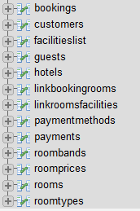

The following picture shows the ER diagram between tables into DB:

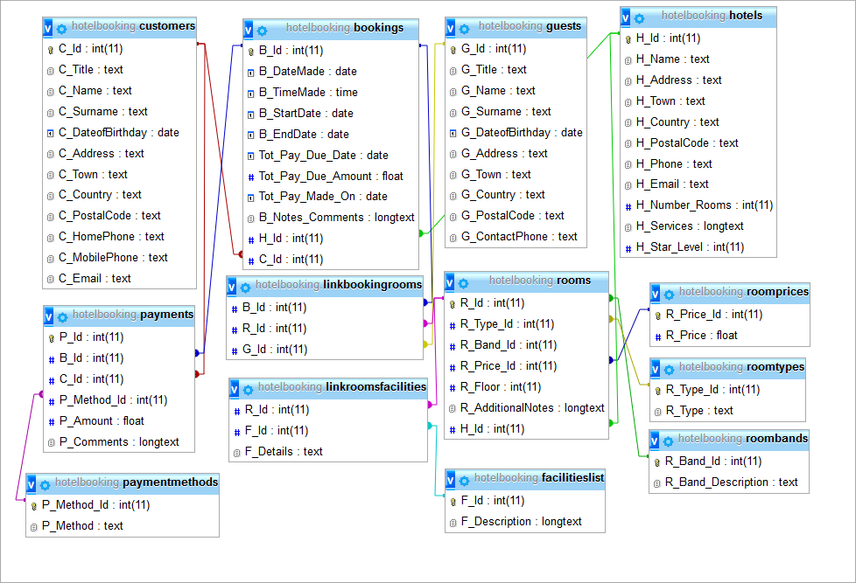

**SQL Query:**

1. Daily sales report
2. Best performer hotels of the day.
3. Weekly accumulated sales.

1)

$today=date(‘Y-M-D’);

$querydailyrep=”SELECT H_Name, SUM(Tot_Pay_Due_Amount) as TOT

FROM hotels as H, bookings as B

WHERE

(H.H_Id=B.H_Id) AND (B.Tot_Pay_Made_On=”.$today.”)

GROUPED BY H_Name”;

2)

$queryCreateview=”CREATE View DailyTotAmount AS

SELECT H_Name, SUM(Tot_Pay_Due_Amount) as TOT

FROM hotels as H, bookings as B

WHERE

(H.H_Id=B.H_Id) AND (B.Tot_Pay_Made_On=”.$today.”)

GROUPED BY H_Name

WITH CHECK OPTION”;

$queryselect=“SELECT H_Name , MAX(TOT)

FROM DailyTotAmount

GROUPED BY H_Name”;

3)

$startdateweek=”2014-08-11”;

$enddateweek=”2014-08-17”;

$queryweeklyrep=”SELECT H_Name, SUM(Tot_Pay_Due_Amount) as TOT

FROM hotels as H, bookings as B

WHERE

(H.H_Id=B.H_Id) AND ((B.Tot_Pay_Made_On<=”.$enddateweek.”) OR (B.Tot_Pay_Made_On>=”.$startdateweek.”))

GROUPED BY H_Name”;